**1)** Name the legislation that applies in the following cases.

(a) An Examination Board allows a software reseller access to its database of centre names and addresses so that the reseller can market its products directly to centres that teach AS Computing.

Data Protection Act

*(1 mark)*

(b) A company using an encryption algorithm in one of its software products receives a demand for royalties from another software company that claims that it invented the encryption algorithm.

Copyright and Patents Act

*(1 mark)*

(c) A user sends an attachment to an e-mail which when opened infects the recipient's computer with a virus.

Computer Misuse Act

*(1 mark)*

(d) A company has its computing equipment seized by the police for using unlicensed commercial software.

Interception of Communications Software

*(1 mark)*

**2)** (a) The term given to techniques which attempt to safeguard the rights of producers of digital material such as computer software or music CDs is Digital Rights Management (DRM).  
DRM uses encryption and authentication systems to curb piracy. Encryption is used to protect the digital material itself, making it unreadable to anyone without the appropriate decryption key.

Explain how authentication would be used to allow users who have paid for the digital material to read it successfully

A password and login would be distributed to users who have paid who will then be able to log on to be allowed access to the digital material to the full extent they are intended. Anybody else would not be able to log on, or at least not as specific people on their private accounts.

*(1 mark)*

(b) There is much debate about the use of DRM. State whether you are in favour or against DRM and describe 2 arguments to support your opinion

I am for DRM because it effectively prevents unauthorized users or criminals accessing content which they have not paid for.

I am against DRM because people who have legitimate access to digital content might forget or lose their login and password and will no longer be able to access it.

*(2 marks)*

**3)** The Data Protection Act was introduced in 1984 in response to a growing level of public concern over the quantity of personal data stored in computer systems. The Act was introduced to protect the individual’s rights to privacy. It was updated in 1998.

Give **one** example of a current or proposed national computer system that could give rise to this concern today. Give **three** reasons why some people are concerned that this system could invade their right to privacy

System Police National Computer *(1 mark)*

Reason 1: It contains information on criminal records which could be slightly wrong, perhaps making someone seem worse than they actually are during a job interview.

*(1 mark)*

Reason 2: The information could be leaked to all sorts of places as the Police National Computer might be a target for hackers. *(1 mark)*

Reason 3: Some people may be denied access to view their own personal information, e.g. criminals records. *(1 mark)*

Define the following key terms used in the Data Protection Act:

Personal data: Data which is specific to one individual who has exclusive rights to control this data.

*(1 mark)*

Data subject: The person or thing the data is about.………………….……………………………………………………………………………………………..

*(1 mark)*

Data Controller: The person responsible for applying for permission to lawfully obtain and store data about something concerning their business or society.……………..……………………………………………………………………………………………..

*(1 mark)*

**Question 4**

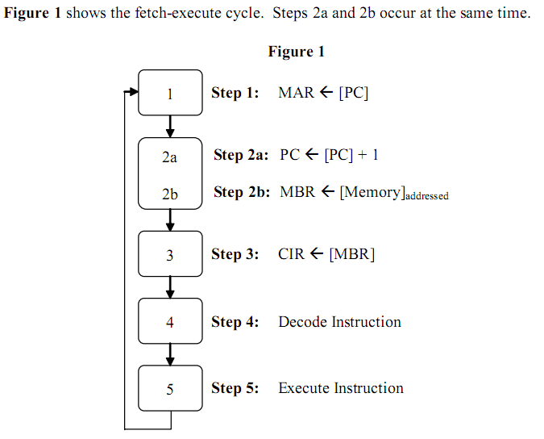

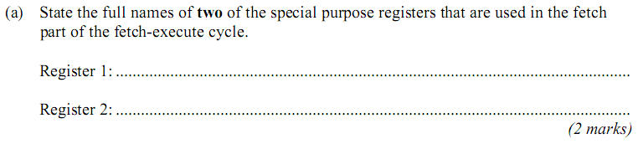

Register 1: Memory Address Register

Register 2: Program Counter

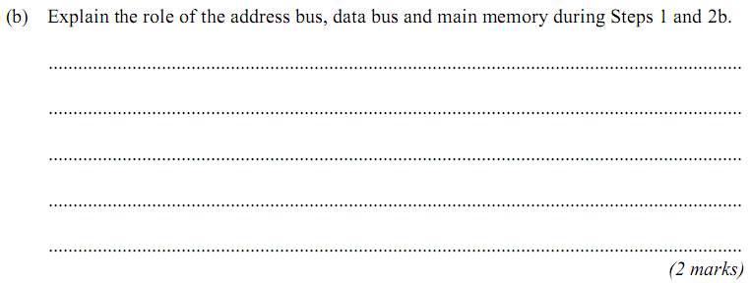

The address bus controls where the instruction travels before it is sent to the MBR. The data bus contains all of the data and transports it between registers. The main memory stores the values generated by each instruction.

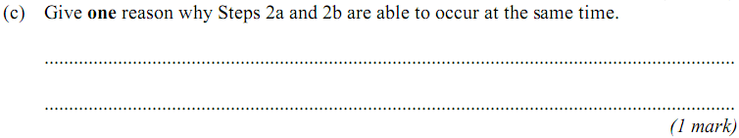

Because the instruction being sent to the MBR triggers another program increment.

**Question 5**

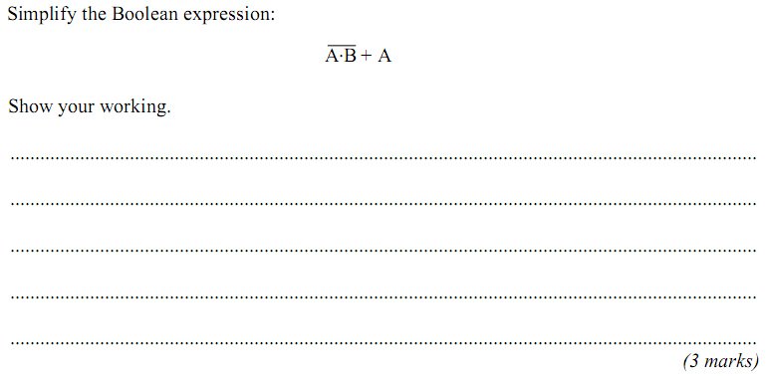

**Question 6**

Explain the principles of operation of a flatbed scanner.

Your answer to this question will also be assessed on your ability to organize your answer clearly and coherently in complete sentences, using specialist vocabulary where appropriate.

(6 marks)

**TOTAL: 28 marks**